**Background:**

* 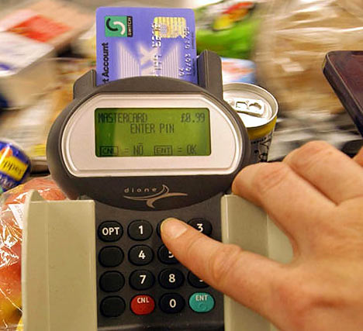PINs (Personal Identification Numbers) are used in a wide   
  range of security applications.
* Four digit PINs (e.g. 1234) are the most common as they are   
  convenient and provide some security. However, six digit PINs   
  (e.g. 123456) should be used whenever possible for improved   
  security.

**Assignment:**

1. Write a simple program that does the following:
   1. Asks the user to enter a 4 digit PIN. This will be the target PIN that the program   
      will try to “crack”.
   2. Runs a loop that starts at 1 and stops when the target PIN is found.
2. Enhance your basic program to include the following code:
   1. The purpose of this code is to measure how long it takes to “crack” the pin.
   2. On average, how long does it take to “crack” a PIN? Try several combinations.

import time

startTime = time.time()

loopCount = 1

while (loopCount <= 1000) :

loopCount = loopCount + 1

endTime = time.time()

print("Elapsed time is:", (endTime - startTime) )

1. Many people use insecure PINs that contain repeated digits such as “1111” or simple sequences such as “1234”.
   1. Enhance your program to try some different digit repeats or digit sequences in order to crack the PIN faster.
   2. Include your enhancements before the main loop.
   3. How does this affect the time needed to “crack” a PIN?
      1. It would solve it almost instantly if it checked common pins
2. Research some other ways that people choose insecure PINs. (e.g. birthday dates)
   1. Enhance your program to check for some of these insecure patterns.
3. Explain how the use of a six digit pin would increase security. Refer to some of the things you discovered while writing the programs for this assignment.
   1. It increases security because the longer a pin, the more attempts a program has to do to cycle through pin combinations to crack the pin.

This Code does all the Questions

import time

import sys

import replit

import math

import itertools

def typer(words):

for char in words:

  time.sleep(0.05)

  sys.stdout.write(char)

  sys.stdout.flush()

def bruteForce(user_pin, length_pin):

  start = time.time()

  attempts = 0

  numbers = "0123456789"

  for x in range(length_pin):

    for number in itertools.product(numbers , repeat=x):

      pin_crack = ''.join(number)

      attempts += 1

      if pin_crack == user_pin:

        end = time.time()

        func_time = end - start

        func_time = round(func_time, 8)

        print()

        print("The Pin Code is " + str(user_pin) + " in " + str(func_time) + " seconds. The PIN code required " + str(attempts) + " attempts to crack!")

        input("Press Enter to Crack Another PIN Code > ")

        return

      else:

        continue

while True:

  print()

  pin_code = (input("Enter Pin: "))

  pin_length = len(pin_code)

  if pin_length < 1 or pin_code.isdigit() == False:

    print("Enter a valid PIN!")

    continue

  else:

    pin_length = pin_length + 1

    bruteForce(pin_code, pin_length)